**Testing Screen Display Sizes**

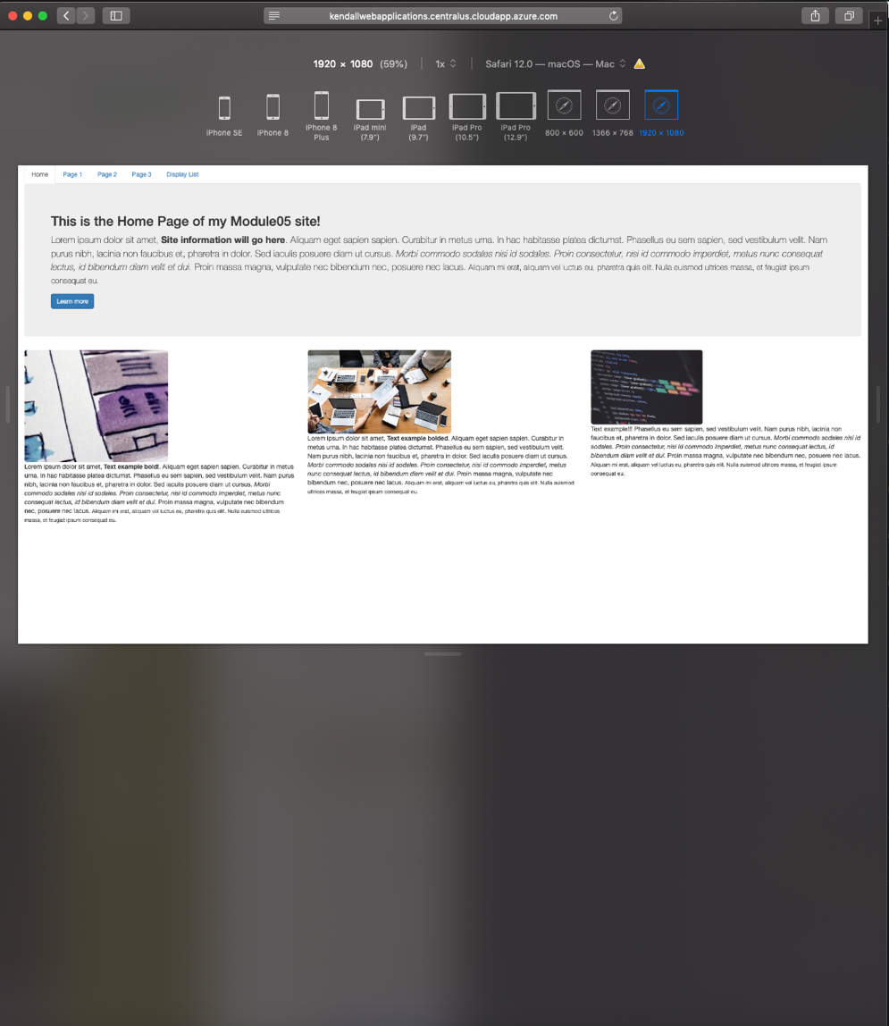

*Module 05 Activity*

Jason Kendall

Fall 2018

1920 x 1080

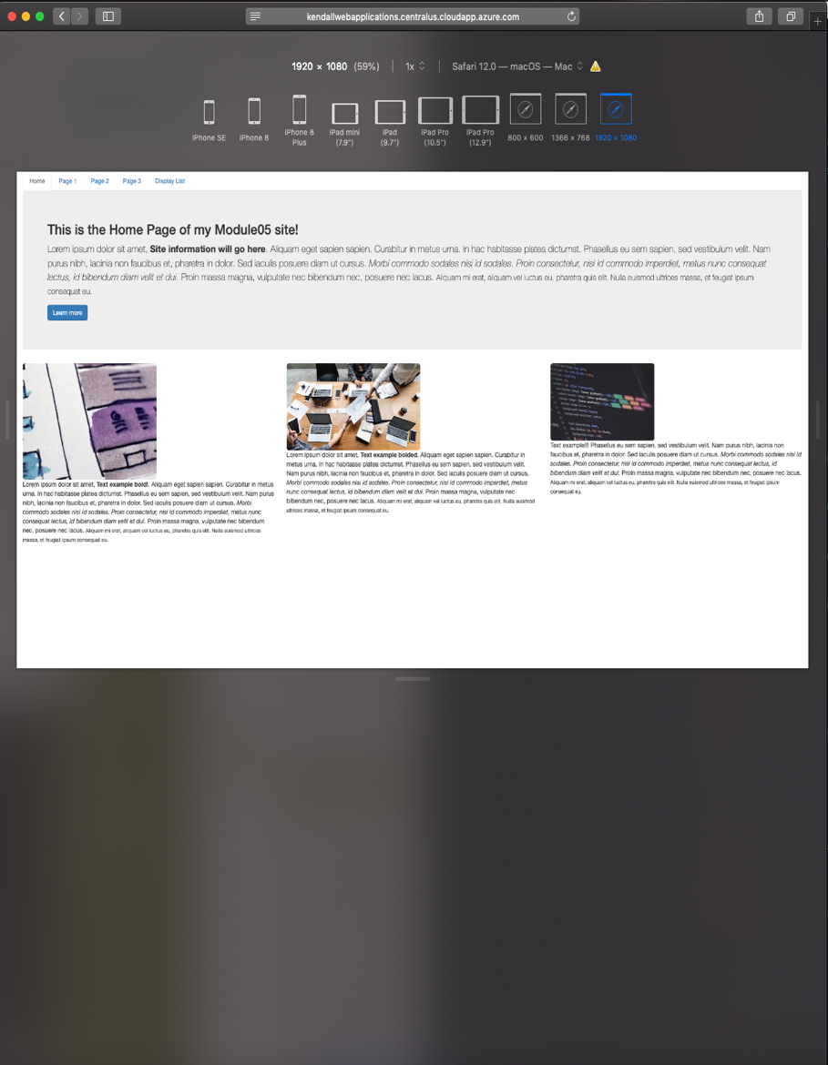

For this project, I utilized the Safari Developer tools which allowed me to render my page to a few different devices, orientations, and aspects windows.

The main thing I noticed with using the 1080 scale was that the content looked pretty small on other devices. This illustrates the importance of Bootstrap and its use of proportion to automatically scale and render the web page.

12.9” (iPad Pro)

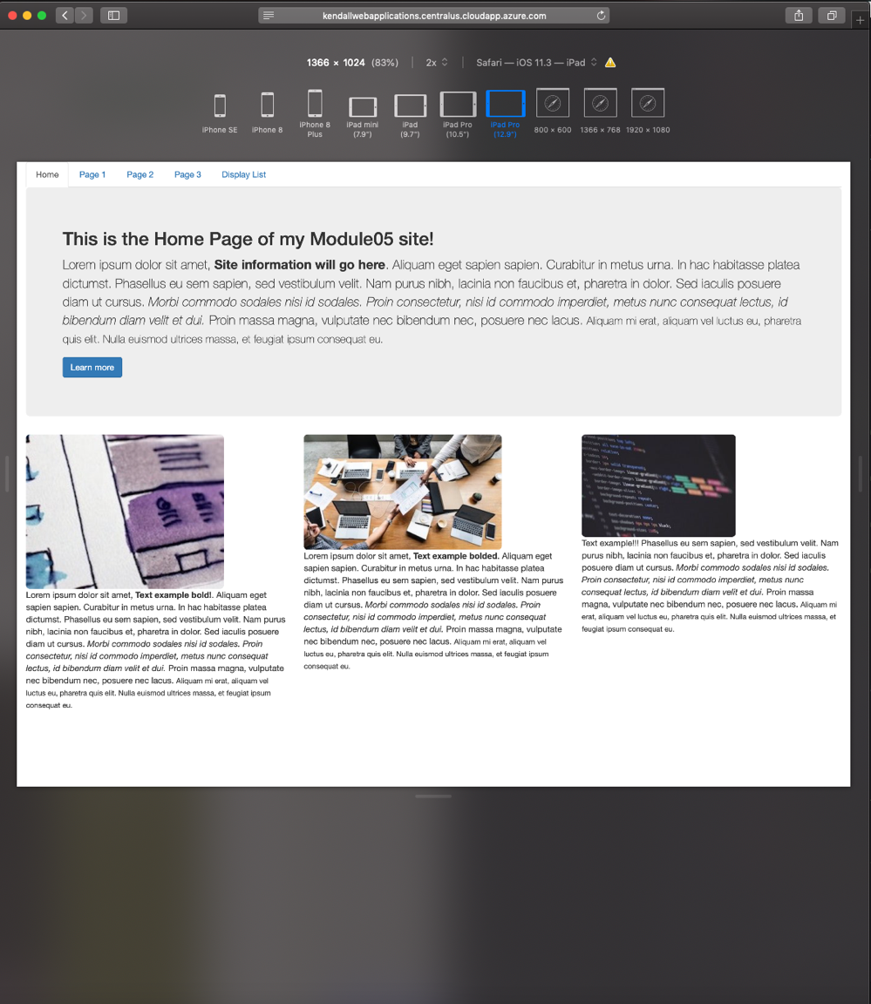

This render looked a little better, the text is much clearer, and the overall layout of the page looks manageable.

If I were to choose a size to display to the web, I would use a smaller size like this, so it looks the best on the greatest number of screens.

iPhone SE

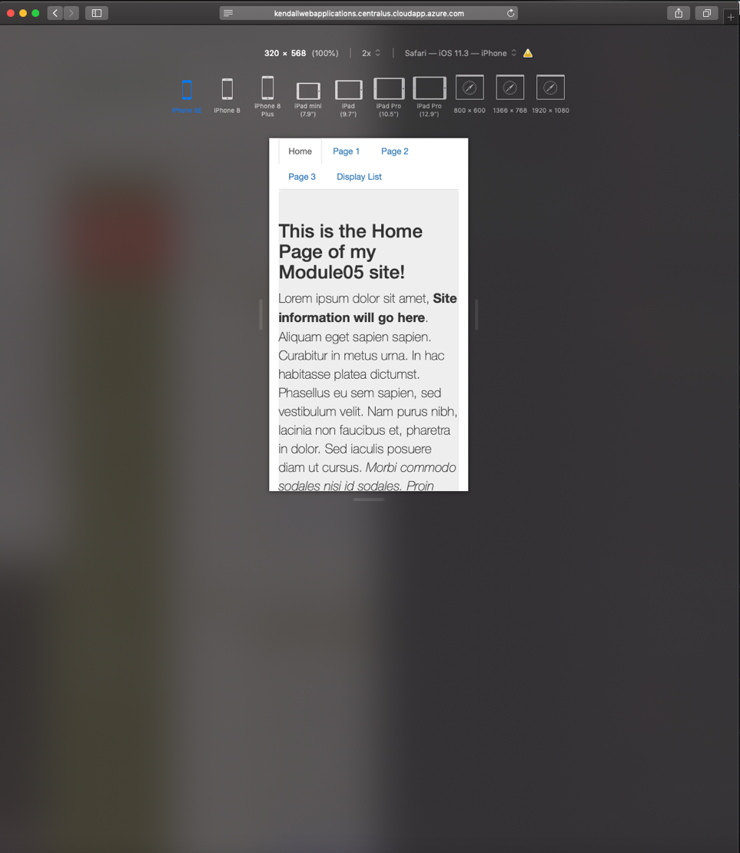

As the last image, this is the smallest render which belongs to the iPhone SE, an earlier model of iPhone. Studies show that the internet is accessed by mobile phones at a much higher rate than desktop-based web browsers. This highlights the importance of developing for mobile first.

It’s amazing how well Bootstrap resizes the content to fit within the page of a very small screen. Obviously, the images do not show but you can scroll down, and they will still be constrained.

Site URL/FQDN:

<http://kendallwebapplications.centralus.cloudapp.azure.com/module05/activity/mod3_ex1/index.html>

GitHub URL:

https://github.com/jasonhkendall/fundamentalwebapps/module05